**Virtual Mouse**

***CHAPTER 1***

**CHAPTER 1**

**INTRODUCTION**

**1.1 Introduction**

A mouse, in computing terms is a pointing device that detects two-dimensional movements relative to a surface. This movement is converted into the movement of a pointer on a display that allows to control the Graphical User Interface (GUI) on a computer platform. There are a lot of different types of mouse that have already existed in the modern days technology, there's the mechanical mouse that determines the movements by a hard rubber ball that rolls around as the mouse is moved. Years later, the optical mouse was introduced that replace the hard rubber ball to a LED sensor to detects table top movement and then sends off the information to the computer for processing. On the year 2004, the laser mouse was then introduced to improve the accuracy movement with the slightest hand movement, it overcome the limitations of the optical mouse which is the difficulties to track high-gloss surfaces. However, no matter how accurate can it be, there are still limitations exist within the mouse itself in both physical and technical terms. For example, a computer mouse is a consumable hardware device as it requires replacement in the long run, either the mouse buttons were degraded that causes inappropriate clicks, or the whole mouse was no longer detected by the computer itself.

Despite the limitations, the computer technology still continues to grow, so does the importance of the human computer interactions. Ever since the introduction of a mobile device that can be interact with touch screen technology, the world is starting to demand the same technology to be applied on every technological devices, this includes the desktop system. However, even though the touch screen technology for the desktop system is already exist, the price can be very steep.

Therefore, a virtual human computer interaction device that replaces the physical mouse or keyboard by using a webcam or any other image capturing devices can be an alternative way for the touch screen. This device which is the webcam will be constantly utilized by a software that monitors the gestures given by the user in order to process it and translate to motion of a pointes, as similar to a physical mouse.

# 1.1 Review Of the Physical Mouse

It is known that there are various types of physical computer mouse in the modern technology, the following will discuss about the types and differences about the physical mouse.

# 1.1.1 Mechanical Mouse

Known as the trackball mouse that is commonly used in the 1990s, the ball within the mouse are supported by two rotating rollers in order to detect the movement made by the ball itself. One roller detects the forward/backward motion while the other detects the left/right motion. The ball within the mouse are steel made that was covered with a layer of hard rubber, so that the detection are more precise. The common functions included are the left/right buttons and a scroll-wheel. However, due to the constant friction made between the mouse ball and the rollers itself, the mouse are prone to degradation, as overtime usage may cause the rollers to degrade, thus causing it to unable to detect the motion properly, rendering it useless. Furthermore, the switches in the mouse buttons are no different as well, as long term usage may cause the mechanics within to be loosed and will no longer detect any mouse clicks till it was disassembled and repaired.

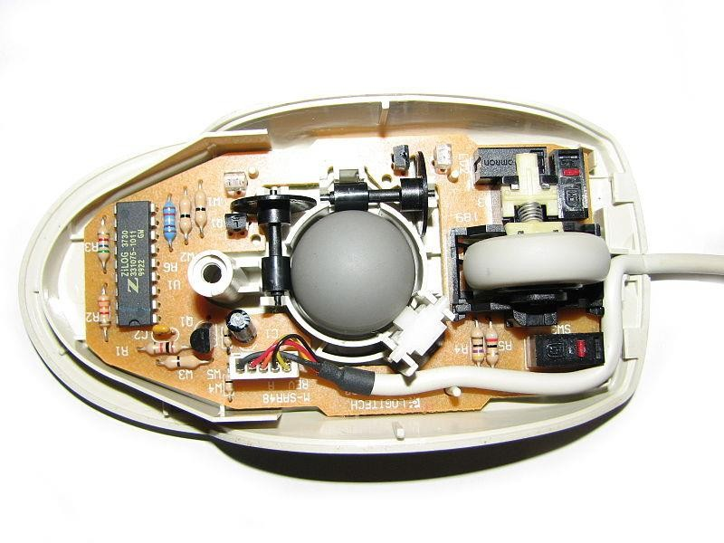

**Figure 1.1** Mechanical mouse, with top cover removed

The following table describes the advantages and disadvantages of the Mechanical Mouse.

|  |  |
| --- | --- |
| Advantage | Disadvantage |
| * Allows the users to control the computer system by moving the mouse. * Provides precise mouse tracking   Movements | * Prone to degradation of the mouse rollers and button switches, causing to be faulty. * Requires a flat surface to operate. |

**Table 1.1:** Advantage and disadvantage of the Mechanical Mouse

# Optical And Laser Mouse

A mouse that commonly used in these days, the motions of optical mouse rely on the Light Emitting Diodes (LEDs) to detect movements relative to the underlying surface, while the laser mouse is an optical mouse that uses coherent laser lights. Comparing to its predecessor, which is the mechanical mouse, the optical mouse no longer rely on the rollers to determine its movement, instead it uses an imaging array of photodiodes. The purpose of implementing this is to eliminate the limitations of degradation that plagues the current predecessor, giving it more durability while offers better resolution and precision. However, there's still some downside, even-though the optical mouse are functional on most opaque diffuse surface, it's unable to detect motions on the polished surface. Furthermore, long term usage without a proper cleaning or maintenance may leads to dust particles trap between the LEDs, which will cause both optical and laser mouse having surface detection difficulties. Other than that, it's still prone to degradation of the button switches, which again will cause the mouse to function improperly unless it was disassembled and repaired.

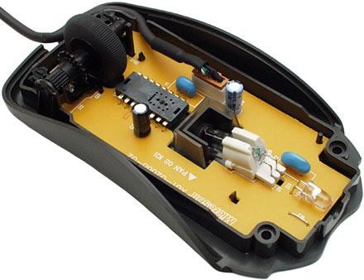

**Figure 1.2** Optical Mouse, with top cover removed

The following table describes the advantages and disadvantages of the Optical and Laser Mouse.

|  |  |
| --- | --- |
| Advantages | Disadvantages |
| * Allows better precision with lesser hand movements. * Longer life-span. | * Prone to button switches degradation. * Does not function properly while   on a polished surface. |

**Table 1.2:** Advantage and disadvantage of the Optical and Laser Mouse

# 1.2. Problem Statement

It's no surprised that every technological devices have its own limitations, especially when it comes to computer devices. After the review of various type of the physical mouse, the problems are identified and generalized. The following describes the general problem that the current physical mouse suffers:

* Physical mouse is subjected to mechanical wear and tear.
* Physical mouse requires special hardware and surface to operate.
* Physical mouse is not easily adaptable to different environments and its performance varies depending on the environment.
* Mouse has limited functions even in present operational environments.
* All wired mouse and wireless mouse have its own lifespan.

# Motivation of Virtual Mouse

It is fair to say that the Virtual Mouse will soon to be substituting the traditional physical mouse in the near future, as people are aiming towards the lifestyle where that every technological devices can be controlled and interacted remotely without using any peripheral devices such as the remote, keyboards, etc. it doesn't just provides convenience, but it's cost effective as well.

# 1.3.1. Convenient

It is known in order to interact with the computer system, users are required to use an actual physical mouse, which also requires a certain area of surface to operate, not to mention that it suffers from cable length limitations. Virtual Mouse requires none of it, as it only a webcam to allow image capturing of user's hand position in order to determine the position of the pointers that the user want it to be. For example, the user will be able to remotely control and interact the computer system by just facing the webcam or any other image capturing devices and moving your fingers, thus eliminating the need to manually move the physical mouse, while able to interact with the computer system from few feet away.

# Cost Effective

A quality physical mouse is normally cost from the range of 30 ringgit to a hefty 400 ringgit, depending on their functionality and features. Since the Virtual Mouse requires only a webcam, a physical mouse are no longer required, thus eliminating the need to purchase one, as a single webcam is sufficient enough to allow users to interact with the computer system through it, while some other portable computer system such as the laptop, are already supplied with a built-in webcam, could simply utilize the Virtual Mouse software without having any concerns about purchasing any external peripheral devices.

# 1.4. Project Scope

Virtual Mouse that will soon to be introduced to replace the physical computer mouse to promote convenience while still able to accurately interact and control the computer system. To do that, the software requires to be fast enough to capture and process every image, in order to successfully track the user's gesture. Therefore, this project will develop a software application with the aid of the latest software coding technique and the open-source computer vision library also known as the OpenCV. The scope of the project is as below:

* Real time application.
* User friendly application.
* Removes the requirement of having a physical mouse.

The process of the application can be started when the user's gesture was captured in real time by the webcam, The software application is compatible with the Windows platform. The functionality of the software will be coded with python programming language code with the integration of an external library that does the image processing known as the OpenCV.

# 1.5. Project Objective

The purpose of this project is to develop a Virtual Mouse application that targets a few aspects of significant development. For starters, this project aims to eliminate the needs of having a physical mouse while able to interact with the computer system through webcam by using various image processing techniques. Other than that, this project aims to develop a Virtual Mouse application that can be operational on all kind of surfaces and environment.

The following describes the overall objectives of this project:

* To design to operate with the help of a webcam.

The Virtual Mouse application will be operational with the help of a webcam, as the webcam are responsible to capture the images in real time. The application would not work if there are no webcam detected.

* To design a virtual input that can operate on all surface.

The Virtual Mouse application will be operational on all surface and indoor environment, as long the users are facing the webcam while doing the motion gesture.

* To program the camera to continuously capturing the images, which the images will be analysed, by using various image processing techniques.

As stated above, the Virtual Mouse application will be continuously capturing the images in real time, where the images will be undergoing a series of process, this includes HSV conversion.

* To convert hand gesture/motion into mouse input that will be set to a particular screen position.

# 1.6. Impact, Significance and Contribution

The Virtual Mouse application is expected to replace the current methods of utilizing a physical computer mouse where the mouse inputs and positions are done manually. This application offers a more effortless way to interact with the computer system, where every task can be done by gestures. Furthermore, the Virtual Mouse application could assist the Clicking and dragging motor functions

**CHAPTER 2**

**CHAPTER 2**

# LITERATURE SURVEY

# LITERATURE REVIEW

As modern technology of human computer interactions become important in our everyday lives, varieties of mouse with all kind of shapes and sizes were invented, from a casual office mouse to a hard-core gaming mouse. However, there are some limitations to these hardware as they are not as environmental friendly as it seems. For example, the physical mouse requires a flat surface to operate, not to mention that it requires a certain area to fully utilize the functions offered.

* 1. **BACKGROUND STUDIES**

Manav Ranawat et al, at 2nd International Conference for Emerging Technology, 2021, presents a model for Hand Gesture Recognition Based Virtual Mouse Events.  This paper provides a detailed explanation to build a virtual mouse application based on the tracking of different hand gestures.  The system eliminates the dependency on any external hardware required to perform mouse actions.  The results are analyzed and where this system has been implemented in Python using OpenCV and PyAutoGUI, A built-in camera tracks the user's hands, predefined gestures are recognized and the corresponding mouse events are executed.

Sharv Dumbre et al, at International Conference on Technological Advancements and Innovations,2021, presents a model for Virtual Mouse using Hand Gestures. The Virtual Mouse provides an infrastructure between the user and the system using only a camera. It allows users to interface with machines without the use of mechanical or physical devices, and even control mouse functionalities. This study presents a method for controlling the cursor’s position without the need of any electronic equipment. While actions such as clicking and dragging things will be carried out using various hand gestures.

Sugnik Roy Chowdhury et al, at 4th International Conference on Trends in Electronics and Informatics,2020, presents a model for Gesture Recognition Based Virtual Mouse and Keyboard.  This paper is proposing a system to recognize the hand gesture and replace the mouse and keyboard function. That includes the movement of the mouse cursor, the drag and click with the keyboard features like printing alphabets and other keyboard functions.  Its application can be very vast in medical science where computation is required but couldn’t fully be implemented due to lack of human computer interaction.

Lisho Thomas et al, at International Research Journal of Engineering and Technology,April 2008, presents a model at Virtual mouse using hand gestures.  This paper proposes a novel camera vision based cursor control system, using hand gestures captured from a webcam through a color detection technique. This system is mainly aimed to reduce the use of hardware components attached with the computer. Although the application can be run in a ordinary computer having a web camera.

Christina.A.Daniel et al, at 5th International Conference on Communication and Electronics Systems,2020, presents a model for Virtual Mouse Using Object Tracking.  A specific interactive module like a virtual mouse that makes use of Object Tracking and Gestures that will help us to interact can be an alternative way for the traditional touch screen and the physical mouse. The objective is to create an Object Tracking application that interacts with the system.  This system proposed is a Computer Vision-based mouse cursor control system, which uses hand gestures that are being captured from a webcam through an HSV color detection technique.

Kollipara Sai Varun et al, at Third International Conference on Trends in Electronics and Informatics, 2019.presents a model for Virtual Mouse Implementation using Open CV.  This paper provides a detailed explanation to the algorithms and methodologies for the color detection and virtual mouse.  The results are analyzed where colour detection algorithms are used to detect the colour caps to identify the mouse pointer.

**CHAPTER 3** 

**CHAPTER 3**

# METHODOLOGY

# 3. METHODS AND TECHNOLOGIES INVOLVED

# 3.1Methodology

This project will develop a software application with the aid of the latest software coding technique and the open-source computer vision library also known as the OpenCV.

The scope of the project is as below:

Real time application.

User friendly application.

Removes the requirement of having a physical mouse.

# Software Requirement

The following describes the software needed in-order to develop the Virtual Mouse application:

* + - * Python Language

Python is a widely used high-level, general-purpose, interpreted, dynamic programming language. Python supports multiple programming paradigms, including object-oriented, imperative and functional programming or procedural styles. It features a dynamic type system and automatic memory management and has a large and comprehensive standard library. Python interpreters are available for many operating systems, allowing Python code to run on a wide variety of systems.

Python uses dynamic typing and a mix of reference counting and a cycle-detecting garbage collector for memory management. An important feature of Python is dynamic name resolution (late binding), which binds method and variable names during program execution. Python has a large standard library, commonly cited as one of Python's greatest strengths, providing tools suited to many tasks

The Python Package Index, the official repository of third-party software for Python, contains more than 72,000 packages offering a wide range of functionality, including: graphical user interfaces, web frameworks, multimedia, databases, networking and communications…test frameworks, automation and Ib scraping, documentation tools, system administration…scientific computing, text processing, image processing.

* + - * Open CV Library

OpenCV are also included in the making of this program. **OpenCV (O**pen **S**ource **C**omputer **V**ision) is a library of programming functions for real time computer vision. OpenCV have the utility that can read image pixels value, it also have the ability to create real time eye tracking and blink detection.

**Software will be using:**

**FUNCTIONAL REQUIREMENTS**

In software engineering, a functional requirement defines a function of a software system or its component. A function is described as a set of inputs, the behavior, and outputs. Functional requirements may be calculations, technical details, data manipulation and processing and other specific functionality that define what a system is supposed to accomplish. Behavioral requirements describing all the cases where the system uses the functional requirements are captured in use cases.

**NON-FUNCTIONAL REQUIREMENTS**

In systems engineering and requirements engineering, a non-functional requirement is a requirement that specifies criteria that can be used to judge the operation of a system, rather than specific behaviors. This should be contrasted with functional requirements that define specific behavior or functions. The plan for implementing functional requirements is detailed in the system design. The plan for implementing non-functional requirements is detailed in the system architecture.

Other terms for non-functional requirements are "constraints", "quality attributes", "quality goals", "quality of service requirements" and "non-behavioral requirements".

Some of the quality attributes are as follows:

* ACCESSIBILITY
* MAINTAINABILITY
* SCALABILITY
* PORTABILITY

**ACCESSIBILITY:**

Accessibility is a general term used to describe the degree to which a product, device, service, or environment is accessible by as many people as possible.

My program interface is simple and efficient and easy to use.

**MAINTAINABILITY:**

In software engineering, maintainability is the ease with which a software product can be modified in order to:

* Correct defects
* Meet new requirements

New functionalities can be added in the project based on the user requirements just by adding the appropriate module and functions to existing project using simple Python GUI.

Since the programming is very simple, it is easier to find and correct the defects and to make the changes in the project.

**SCALABILITY:**

System is capable of handling increase total throughput under an increased load of data when resources (typically hardware) are added.

System can work normally under situations such as low bandwidth and using less hardware resources.

**PORTABILITY:**

Portability is one of the key concepts of high-level programming. Portability is the software code base feature to be able to reuse the existing code instead of creating new code when moving software from an environment to another.

Project can be executed under different operation conditions provided it meets its minimum configurations. Only python environment and common libraries would have to be configured in such case.

**3.2.1 HARDWARE REQUIREMENTS**

|  |  |
| --- | --- |
| **HARDWARE** | **SPECIFICATION** |
| PC | WINDOWS 7 and above |
| Webcam | 720 width×480 height  0.346 mega pixels  30 frame/second |

**3.3.2SOFTWARE REQUIREMENTS**

|  |  |
| --- | --- |
| **SOFTWARE** | **SPECIFICATION** |
| Pycharm - OpenCV Library | 2021.3.2 version |

**CHAPTER 4**



**CHAPTER 4**

# SYSTEM IMPLEMENTATION

**4.1. Implementation**

This AI Virtual Mouse proposes a novel camera vision based cursor control system, using hand gestures captured from a webcam through a color detection technique.The system will allow the user to navigate the computer cursor using their hand bearing color caps or tapes and left click and dragging will be performed using different hand gestures.

The proposed system uses nothing more than a low resolution webcam that acts as a sensor and it is able to track the users hand gestures. The system will be implemented using the python and OpenCV.

The hand gesture is the most effortless and natural way of communication. The output of the camera will be displayed on the monitor. Shape and position information about the gesture will be gathered and will work under the set frame. The file transferring scheme is implemented by using the python server programming.

This Virtual Mouse Hand Recognition application uses a the gesture recognition and hand landmarks on the finger without the additional requirement of the hardware for the controlling of the cursor resulting in use of simple gestures and hand control. This is done using vision-based hand gesture recognition with inputs from a webcam.

The designing of virtual mouse involves the following steps:

* Install OpenCV library
* Setup webcam functions and test it
* Capturing Frames
* Detecting the hand landmarks
* Track the movement and its click-based points in hand landmarks.
* The Smoothening of the mouse movements.

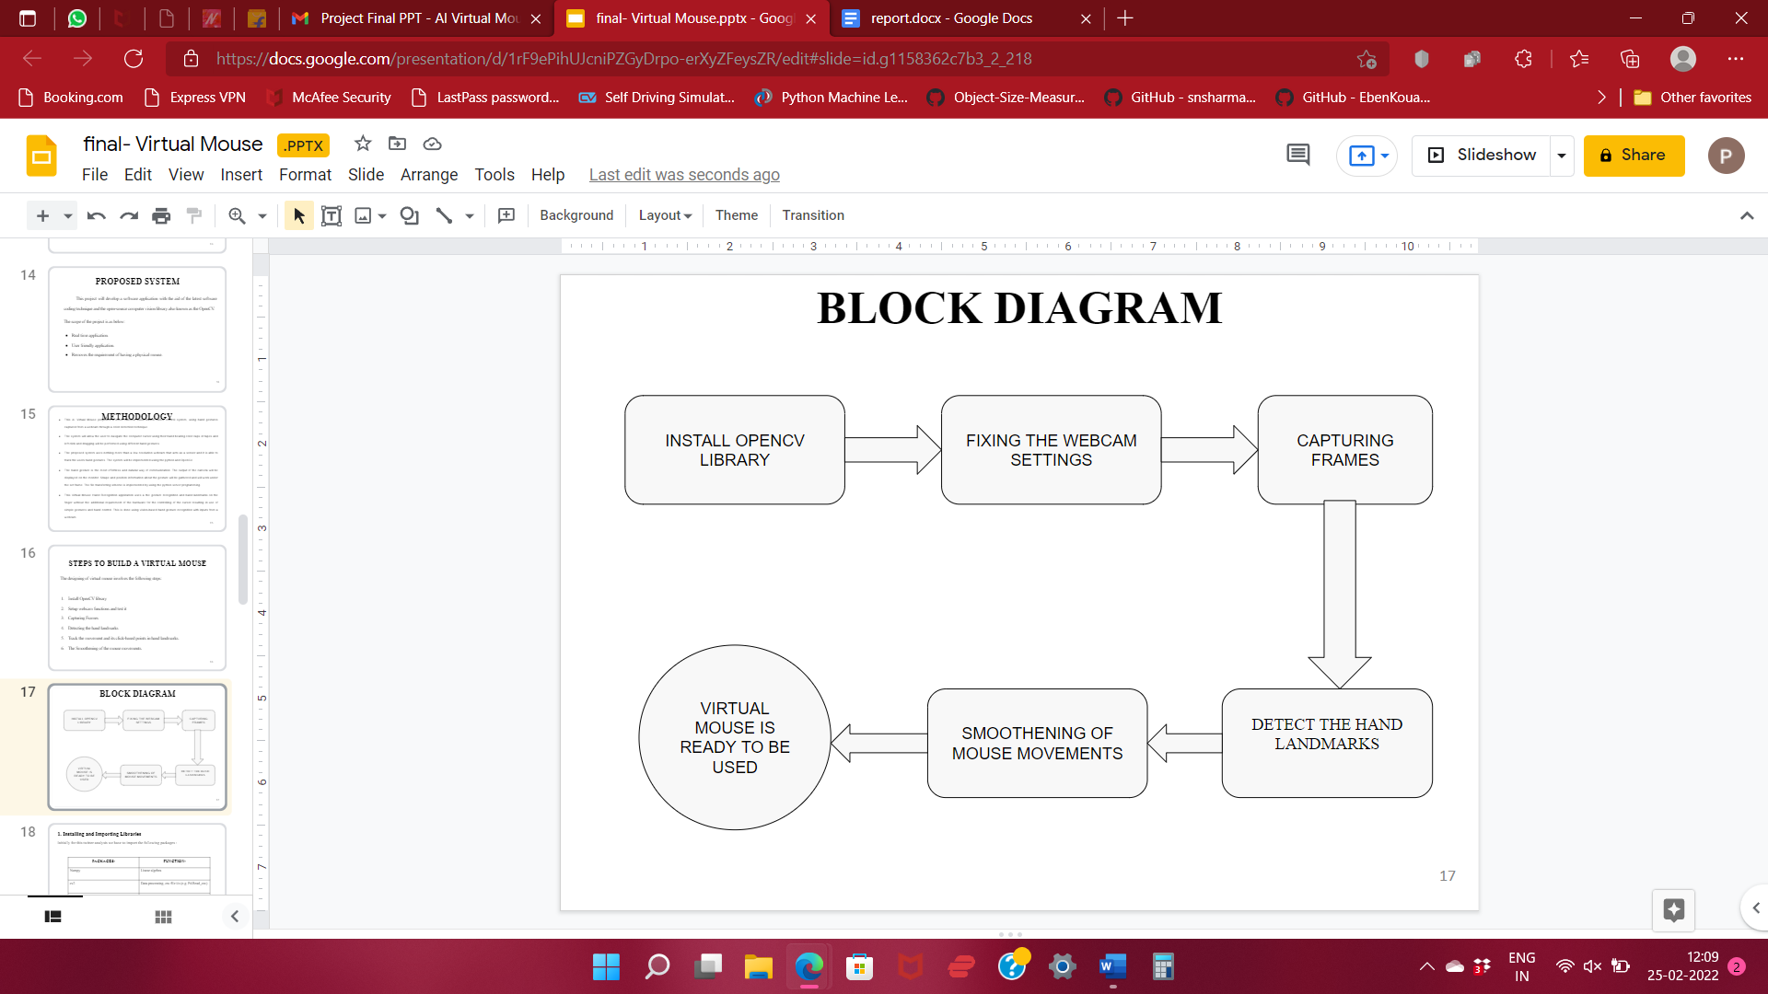

**4.1.1 Installing and Importing Libraries**

Initially for this twitter analysis we have to import the following packages :

|  |  |
| --- | --- |
| **PACKAGES:** | **FUNCTION:** |
| Numpy | Linear algebra |
| cv2 | Data processing, csv file i/o (e.g. Pd.Read_csv) |
| Mediapipe | Build world-class ML solutions |
| Autopy | Cross-platform GUI automation library |
| Hand_Movement_Tracking | Track the hand movements |

**4.1.2  Webcam Settings, Frame Reduction and Frame Rate**

* The runtime operations are managed by the webcam of the connected laptop or desktop. To capture a video, we need to create a Video Capture object.
* After that, you can capture frame-by-frame. But at the end, don’t forget to release the capture.
* The infinite loop is used so that the web camera captures the frames in every instance and is open during the entire course of the program.
* We capture the live feed stream, frame by frame and set Frame Rate.
* Then we process each captured frame which is in RGB(default) color space to HSV color space.
* There are more than 150 color-space conversion methods available in OpenCV.
* But we will look into only two which are most widely used ones, BGR to Gray and BGR to HSV

**4.1.3.  DETECT THE HAND LANDMARKS**

 The webcam captures the hand in the set frame. Then, when the image of hand captured is successThe hand is captured and the landmarks given below are set. The below are the quantities that sets detects the Hand Landmarks.

1. image:   The input image with prominent hand(s) whose landmarks needs to be detected.
2. hands:   The hands function required to perform the hands landmarks detection.
3. display: A boolean value that is if set to true the function displays the original input image, and the output image with hands landmarks drawn and returns nothing.

The image below shows the twenty-one hand landmarks, that this solution detects, along with their indexes.

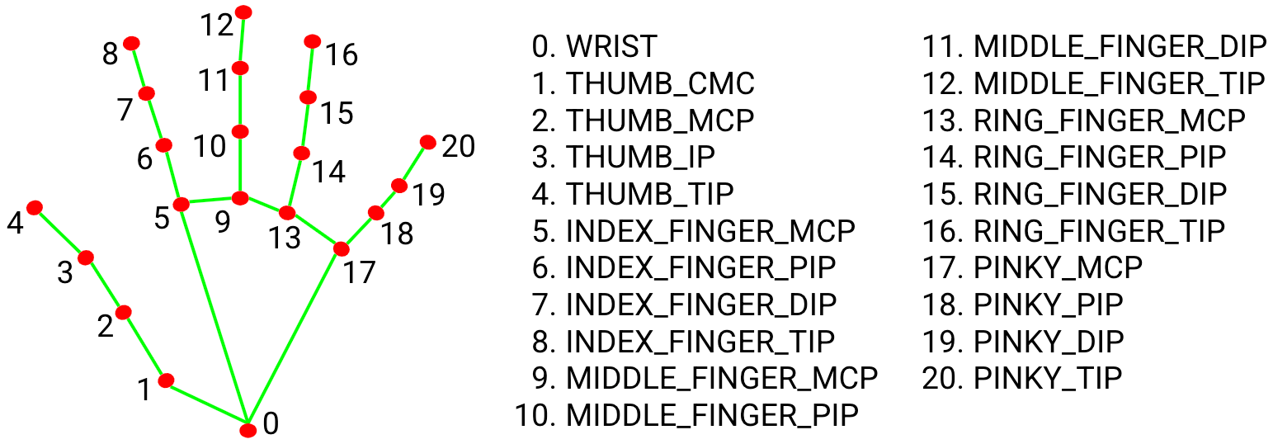

Fig 4.1 Shows the twenty-one hand landmarks

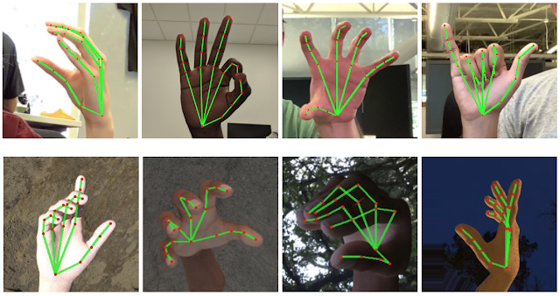

Fig 4.2 Indices of hand movements

**4.1.4. Mouse Movements and Smoothening the movements**

Setting the mouse movements is the next step by converting the detected coordinate from the hand landmarks.

The steps included are:

* Check which fingers are up
* Only Index Finger : Moving Mode

                       Convert Coordinates

                       Smoothen Values

                        Move Mouse

* Both Index and middle fingers are up : Clicking Mode

**OUTPUT**

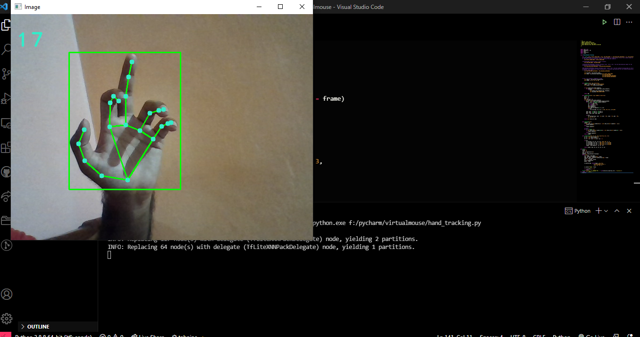

Fig 4.3 Output – clicking operations

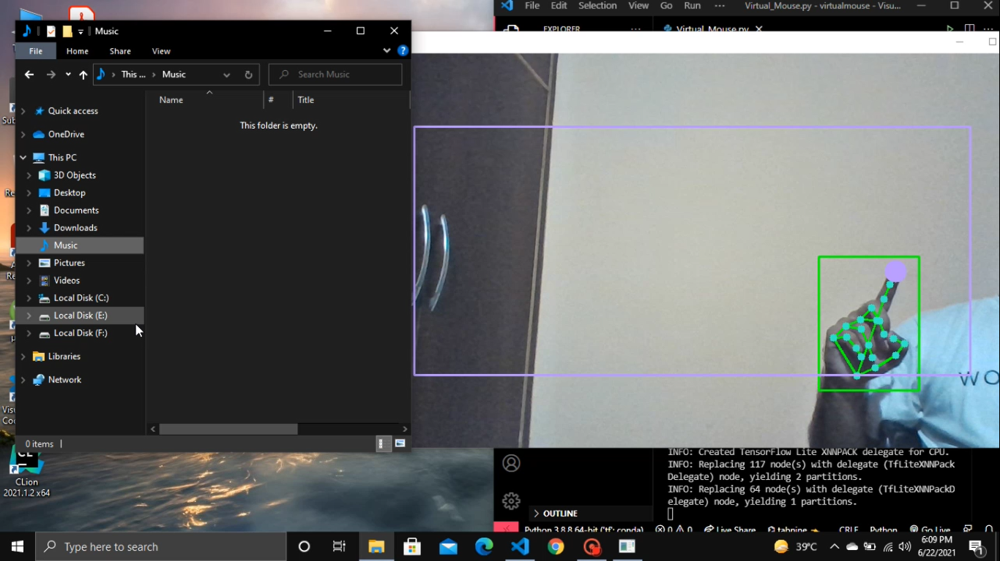

Fig 4.3 Output- Drag operations

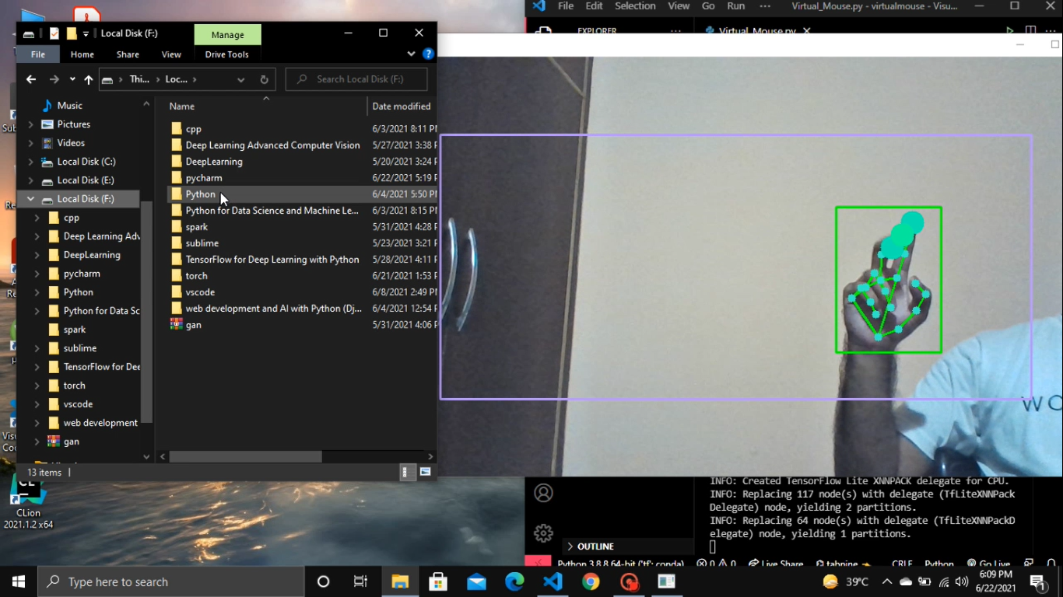

Fig 4.4 Output- Right click operations

**CHAPTER 5**

**CHAPTER 5**

# CONCLUSION AND FUTURE WORK

**5. Overview**

Creating a AI Virtual Mouse using Python OpenCV Library. Developed by a system to control the mouse cursor using Python and OpenCV with the real-time camera.

 The packages used are

* OpenCV
* Mediapipe
* Autopy

 Fingertip location is mapped to RGB images to control the mouse cursor. Moving mode and clicking mode are created in using this virtual mouse.

* This AI Virtual Mouse proposes a novel camera vision based cursor control system, using hand gestures captured from a webcam through a color detection technique.
* The system uses nothing more than a low resolution webcam that acts as a sensor and it is able to track the users hand gestures. The system will be implemented using the python and OpenCV.
* The hand gesture is the most effortless and natural way of communication. The output of the camera will be displayed on the monitor. Shape and position information about the gesture will be gathered and will work under the set frame. The file transferring scheme is implemented by using the python server programming.
* This Virtual Mouse Hand Recognition application uses a the gesture recognition and hand landmarks on the finger without the additional requirement of the hardware for the controlling of the cursor resulting in use of simple gestures and hand control. This is done using vision-based hand gesture recognition with inputs from a webcam.

# 5.2. Future Works

There are several features and improvements needed in order for the program to be more user friendly, accurate, and flexible in various environments. The following describes the improvements and the features required:

1. Smart Recognition Algorithm

Due to the current recognition process are limited within 25cm radius, an adaptive zoom-in/out functions are required to improve the covered distance, where it can automatically adjust the focus rate based on the distance between the users and the webcam.

1. Better Performance

The response time are heavily rely on the hardware of the machine, this includes the processing speed of the processor, the size of the available RAM, and the available features of webcam. Therefore, the program may have better performance when it's running on a decent machines with a webcam that performs better in different types of lightings.

**BIBLIOGRAPHY**

# BIBLIOGRAPHY



[1] G.S. Mahitha, B. Revanth, G. Geetha and R. Sirisha, "Hand Gesture Recognition to Implement Virtual Mouse Using Open Source Computer Vision Library: Python", Proceedings of International Conference on Advances in Computer Engineering and Communication Systems,2021.

[2]  S.S. Abhilash, L. Thomas, N. Wilson and C. Chaithanya, "Virtual Mouse Using Hand Gesture", International Research Journal of Engineering and Technology (IRJET), 2018.

[3] Abhik Banerjee, Abhirup Ghosh, Koustuvmoni Bharadwaj,” Mouse Control using a Web Camera based on Color Detection”,IJCTT,vol.9, Mar 2014.

[4] Angel, Neethu.P.S,”Real Time Static & Dynamic Hand Gesture Recognition”, International Journal of Scientific & Engineering Research Volume 4, Issue3, March-2013.

[5] Q. Y. Zhang, F. Chen and X. W. Liu, “Hand Gesture Detection and Segmentation Based on Difference Background Image with Complex Background,” Proceedings of the 2008 International Conference on Embedded Software and Systems,July 2008.

[6] Cheong Soon Nyean, Yap Wen Jiun and Chan Mun Leong, "Cost-effective wiimote-based technology enhanced teaching and learning platform", 2nd International Conference of Teaching and Learning (ICTL), 2009.

[7] A.A. Argyros and M.I. Lourakis, "Vision-based interpretation of hand gestures for remote control of a computer mouse", European conference on computer vision, 2006.